CAPSTONE PROJECT
FEEDBACK RATING SYSTEM

INTRODUCTION

Feedback plays a crucial role in improving the quality of services across various sectors. In many environments—such as garages, service centers, coaching institutes, and local businesses—customers often lack a structured platform to share their experiences. Traditional feedback processes are either manual, inconsistent, or inaccessible, leading to a gap between service providers and users. To address this challenge, the Feedback and Rating Management System has been developed as a web-based application that enables users to register, log in, and provide transparent feedback for different service providers.
The system centralizes all feedback data and provides role-based access for Users, Service Providers, and Administrators. Users can submit feedback and ratings, view or edit their previous reviews, and search feedback given by others. Service Providers can monitor feedback related to their services, analyze customer satisfaction trends, and improve service quality accordingly. The Admin has full control over managing users, providers, and ensuring the platform operates smoothly.
This project integrates both frontend and backend components. The frontend is developed using HTML, CSS, and JavaScript, providing an intuitive and responsive interface. The backend is implemented using Spring Boot, ensuring security, scalability, and efficient API processing. The system uses JWT authentication for secure access and follows a modular architecture to maintain separation of concerns.
Overall, this project aims to create a reliable and user-friendly platform that enhances transparency, improves service accountability, and empowers users to voice their experiences effectively. It serves as a digital solution that bridges communication between customers and service providers while ensuring that feedback is managed systematically and efficiently.

ABSTRACT

The Feedback and Rating Management System is a comprehensive web-based application developed to streamline the collection, analysis, and management of user feedback across various service categories. In many real-world scenarios, customers face difficulties in conveying their experiences, and service providers struggle to obtain structured insights that can help them improve. This system addresses these challenges by offering a unified platform where users can provide honest reviews, rate service providers, and track their submitted feedback, thereby promoting transparency and service quality enhancement.
The system is designed with three interacting modules—User, Service Provider, and Admin—each contributing to the overall workflow. Users can register, log in, submit feedback with a rating, view or edit their own feedback entries, and make use of search and filtering features to explore existing reviews. Service providers can access the feedback submitted about their services and use the insights to understand customer expectations. The Admin module ensures smooth platform functioning by managing user accounts, monitoring activities, and maintaining system integrity.
The application employs HTML, CSS, and JavaScript for the frontend, providing a responsive and user-friendly interface. The backend is built using Spring Boot, enabling robust API development, secure communication, and efficient request handling. Security is maintained through JWT-based authentication, ensuring protected access to system resources. The project follows a modular architecture, making the solution scalable, maintainable, and easy to enhance in the future.
The main objective of this system is to bridge the communication gap between customers and service providers while creating a reliable mechanism for quality assessment. By digitizing the feedback process, the system contributes to better decision-making, improved service standards, and enhanced user satisfaction. This project demonstrates the effective integration of modern web technologies to solve a real-world problem in a structured and scalable manner.

SYSTEM REQUIREMENTS

To ensure the smooth functioning of the Feedback Rating System, both software and hardware components are required. These requirements allow the project to run efficiently during development, testing, and deployment stages.
Software Requirements
- Operating System
Windows 10 or above (suitable for development, running the server, and testing the frontend).
- Backend Technologies
• Java 17
• Spring Boot Framework
• Spring Security for authentication and role-based access
• Maven for dependency management and project build
• MySQL 8.0 for database management
- Frontend Technologies
• HTML5
• CSS3
• Vanilla JavaScript
• Fetch API for API communication
These allow the frontend to run on any standard browser without additional frameworks.
- Development Tools
• STS (Spring Tool Suite) or IntelliJ IDEA for backend development
• Visual Studio Code or any text editor for frontend development
• Postman for API testing and validation
• Git and GitHub for version control
- Browser Support
The application is compatible with all modern browsers such as Chrome, Edge, and Firefox.
Hardware Requirements
- Processor
Minimum Intel Core i3 or equivalent for running the Spring Boot server and database smoothly.
- RAM
A minimum of 8 GB RAM is recommended, as running both the server and database simultaneously requires moderate memory.
- Storage
At least 2 GB of free disk space for the project files, dependencies, MySQL data, and logs.
- Display
Any standard monitor with 1366 × 768 resolution or higher.
These requirements collectively provide a stable environment to build, execute, and test the Feedback Rating System. The system is lightweight and can run on commonly available hardware, making it suitable for both academic and real-world environments.

PROJECT MODULES
The Feedback Rating System is designed as a modular application where each component performs a specific function within the overall platform. Breaking the system into modules ensures clarity, maintainability, and ease of understanding. The major modules developed in this project are described below.
1. User Authentication Module
This module manages the registration and login functionalities for all users—customers, service providers, and admins.
It includes secure password handling, JWT-based authentication, and role assignments.
Users gain access to different dashboards based on their assigned roles.
2. Feedback Submission Module
This module allows customers to submit feedback for any service provider registered in the system.
Users can enter comments, give a rating, and send their feedback through a simple interface.
Once submitted, the data is stored securely in the database.
3. Feedback Management Module
Service providers and admins can view feedback submitted by customers.
Providers get access only to the reviews directed at them, while admins can view all feedback across the platform.
This module helps monitor service quality and understand user satisfaction.
4. Feedback Search Module
Users can search for feedback using keywords.
This helps quickly locate specific reviews or understand feedback trends for a particular provider or topic.
The search results are displayed dynamically for ease of access.
5. Feedback Filtering Module
This module enables filtering feedback based on rating range and date.
Users can refine results to analyze feedback patterns, find recent reviews, or view only positive/negative ratings.
It is especially useful for providers tracking performance improvements over time.
6. Provider Dashboard Module
This module gives service providers a dedicated panel where they can view their feedback, check ratings, and understand customer sentiment.
It helps them take corrective actions, maintain service quality, and track their performance.
7. Admin Management Module
Admins have the highest level of access.
They can manage users, view providers, delete unwanted feedback, and keep the platform secure.
This module ensures smooth functioning of the entire system.
8. Frontend User Interface Module
All user-facing screens—login, registration, dashboards, search, filter, and feedback submission—are built with HTML, CSS, and JavaScript.
This module ensures a clean layout, smooth navigation, and a user-friendly experience.
These modules collectively form a complete and functional feedback management system that supports secure access, efficient feedback handling, and meaningful insights for both customers and service providers.

ER DIAGRAM AND ARCHITECTURE

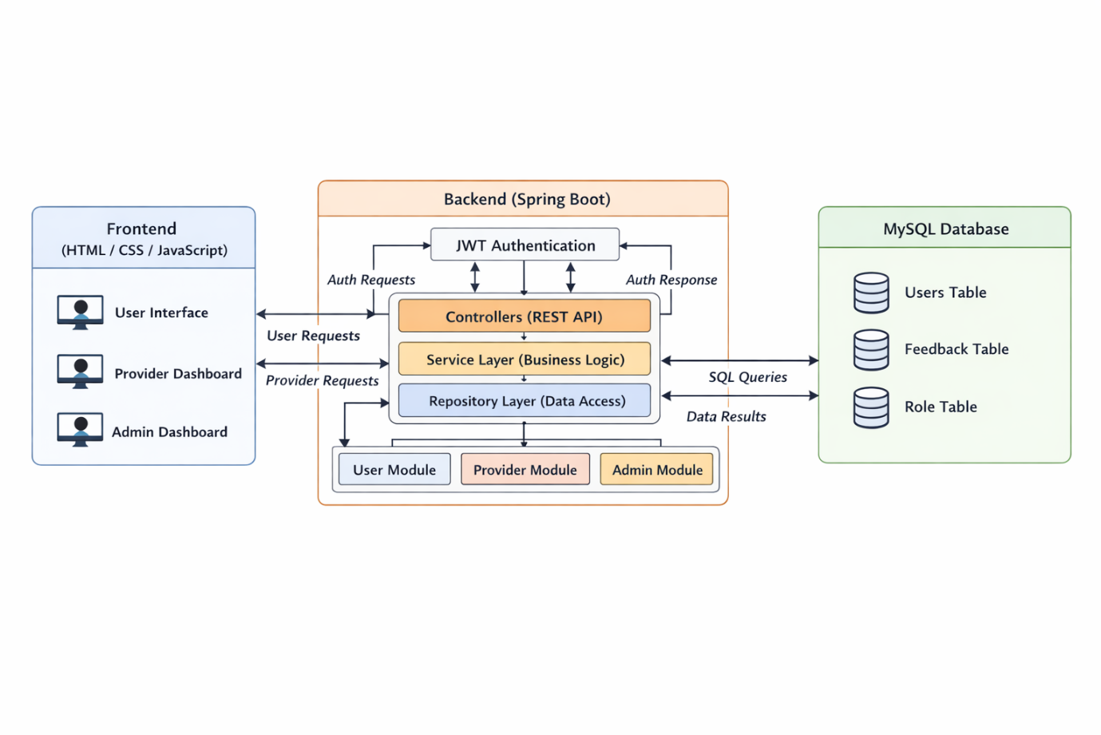
The architecture follows a clean three-tier design that separates concerns clearly and improves maintainability.
The frontend layer (HTML, CSS, and JavaScript) handles all user interactions through role-based dashboards for users, providers, and admins. These requests are sent to the backend layer, built using Spring Boot, where REST controllers manage incoming requests and JWT-based authentication ensures secure access. The service layer processes business logic, while the repository layer communicates with the MySQL database, which stores users, roles, and feedback data.
This structured flow ensures secure communication, modular development, and efficient data handling across the entire system.

USER AUTHENTICATION MODULE

The User Authentication Module forms the foundation of the Feedback Rating System. It ensures that only authorized individuals can access the application and perform specific tasks based on their assigned roles. This module handles the complete login and registration workflow and is designed with a strong emphasis on security and role-based access.
The registration process allows new users—customers, service providers, and administrators—to create an account by providing basic details such as name, email, and password. During registration, each user is assigned an appropriate role which determines the type of dashboard and features they can access. This role-based structure ensures that customers can submit feedback, providers can view feedback related to their services, and administrators can oversee the entire system.
The login process is secured using JWT (JSON Web Tokens). When a user logs in with valid credentials, the system generates a token that is used to authenticate all subsequent API requests. This eliminates the need for repeated credential verification while maintaining a high level of security. The token also contains encoded role information, which helps the system authorize actions such as accessing dashboards or performing administrative operations.
Password protection is handled using strong hashing techniques to ensure that user information remains secure even if the database is compromised. The system verifies passwords without ever storing them in plain text. Error handling is also incorporated to provide user-friendly messages when invalid credentials are entered.
Overall, the User Authentication Module ensures a smooth, secure, and role-appropriate entry point into the Feedback Rating System. It forms a crucial component of the project, enabling safe interactions and controlled access across all other modules.

FEEDBACK SUBMISSION MODULE

The Feedback Submission Module is one of the core components of the Feedback Rating System and is primarily used by customers to share their experience with a particular service provider. This module enables users to give structured and meaningful feedback in the form of comments and ratings, which are later visible to the respective provider and the administrative team.
The process begins on the user dashboard, where customers can select a service provider and submit their review. The form typically includes fields such as rating (on a predefined scale) and an optional descriptive comment. These inputs allow customers to express both quantitative and qualitative opinions about the service they received. Once submitted, the feedback is permanently stored in the database along with the customer’s identity, the provider’s identity, and the timestamp of submission.
The module includes validation to ensure that users provide appropriate and complete information before submitting. For example, the rating field is mandatory and must fall within a valid range. The system also checks whether the user attempting to submit feedback is authenticated and authorized to do so. This ensures that only legitimate users can provide reviews and eliminates the possibility of unauthorized entries.
Upon successful submission, the data is processed by the backend and stored using well-defined relational mappings. Each feedback entry is linked to the corresponding user and service provider, allowing both dashboards to reflect real-time updates. Providers can later view these reviews on their respective dashboards, giving them insights into customer satisfaction and areas of improvement.
In summary, the Feedback Submission Module makes it easy for customers to communicate their experiences and supports the overall goal of the project by fostering transparency, accountability, and continuous improvement among service providers.

FEEDBACK MANAGEMENT MODULE

The Feedback Management Module is responsible for handling all operations related to viewing, updating, organizing, and interpreting the feedback submitted by users. It serves as a central component where both users and service providers can interact with previously submitted reviews in a structured and systematic manner.
For service providers, this module offers access to all feedback entries associated with their services. Providers can view customer comments, analyze rating patterns, and identify areas that require improvement. This helps them gain practical insights into customer expectations and take corrective actions wherever necessary. The system ensures that providers only access feedback relevant to them, maintaining data privacy and proper authorization at every step.
For users, the module allows them to revisit the feedback they previously submitted. Users can also edit or delete their reviews within allowed conditions, ensuring that their feedback remains accurate and reflective of their true experience. All modifications are validated by the backend to ensure data consistency and prevent misuse.
Administratively, the module also supports various management functionalities such as filtering feedback by rating range, searching for feedback using keywords, and generating summaries like average ratings for each provider. These additional tools make it easier to evaluate overall service quality and track performance trends over time.
All feedback entries are stored in a secure database with proper relational mapping. This ensures seamless retrieval and enables efficient operations even when handling large volumes of data. The module integrates closely with other backend services such as authentication, authorization, and database management to deliver a smooth and reliable user experience.
Overall, the Feedback Management Module strengthens the system by ensuring that feedback is not only collected but also effectively utilized, enabling meaningful interactions between users, providers, and administrators.

FEEDBACK SEARCH MODULE

The Feedback Search Module enables users and administrators to quickly locate specific feedback entries using keyword-based search functionality. As the number of feedback records grows, manually browsing through each entry becomes inefficient. This module provides an intuitive and powerful way to retrieve relevant feedback without navigating through large datasets.
Users can enter any keyword—such as a service name, provider name, or a specific term mentioned in the comments—and the system immediately returns a filtered list of matching results. This allows users to revisit important reviews, compare their experiences, or verify whether they have already submitted feedback for a particular service.
For service providers, the search feature acts as a valuable analytical tool. Providers can search for recurring issues or frequently mentioned concerns, allowing them to identify common patterns and make improvements based on customer expectations.
Administrators can also make use of this module to monitor system activity and ensure that feedback remains constructive and aligned with platform policies. By searching for particular words or phrases, administrators are able to detect inappropriate content or identify service quality issues across the platform.
The backend implementation uses optimized database queries to ensure that search results are generated efficiently, even when large volumes of data are present. Keyword matching is performed on the comment field of feedback entries, ensuring that the search remains relevant and meaningful.
Overall, the Feedback Search Module enhances the usability of the system by providing fast, accurate, and convenient access to specific feedback entries, greatly improving the experience for users, providers, and administrators alike.

FEEDBACK FILTERING MODULE

The Feedback Filtering Module enhances the system’s usability by allowing users, service providers, and administrators to refine large volumes of feedback based on specific criteria. Instead of scrolling through every entry, users can instantly narrow down feedback to the most relevant results, improving both efficiency and decision-making.
This module primarily supports two types of filters: rating-based filtering and date-based filtering. Rating-based filtering helps users view feedback within a particular rating range, such as highly positive feedback (4–5 stars) or lower-rated feedback that may highlight issues. Service providers often rely on this feature to assess customer satisfaction trends and identify areas needing improvement.
Date-based filtering allows users to view feedback submitted within a specific time frame—such as weekly, monthly, or custom date ranges. This is particularly useful for providers who want to evaluate recent performance or compare feedback trends over time.
Administrators also benefit from this module, as filtering helps them monitor feedback quality and detect sudden spikes in negative reviews that may indicate service issues. With clear and focused results, they can respond more effectively and maintain the overall credibility of the system.
The backend implementation ensures that filtered data is retrieved quickly using optimized database queries, even when dealing with large datasets. By combining rating and date filters, the system provides a highly flexible and user-friendly way to analyze customer feedback.
Overall, the Feedback Filtering Module strengthens the platform by offering precise control over feedback visibility, making it easier for all stakeholders to extract meaningful insights and take informed actions.

PROVIDER DASHBOARD MODULE

The Provider Dashboard Module is designed to give service providers a dedicated and organized view of all the feedback submitted for their services. It acts as a centralized control panel where providers can monitor customer experiences, understand satisfaction levels, and identify areas that require attention.
This dashboard displays key information such as recent feedback, overall ratings, and trends over time. By having these insights in one place, providers can easily assess how well they are performing and make improvements where necessary. The interface is kept simple and intuitive to ensure that even non-technical users can navigate it without difficulty.
One of the major benefits of this module is its ability to help providers understand customer expectations. For example, a garage or repair shop can see whether customers appreciate punctuality, pricing, service quality, or communication. Repeated concerns mentioned in feedback can be quickly spotted, allowing providers to take corrective measures before issues grow.
The dashboard also allows providers to respond to customer feedback where applicable, helping build trust and maintain transparency. Through real-time updates, service providers can stay informed about new feedback as soon as it is submitted. This makes it easier to track ongoing performance and maintain a consistent quality of service.
Overall, the Provider Dashboard Module supports service providers by offering meaningful insights, improving customer engagement, and helping them strengthen the reliability of their services. It plays an essential role in maintaining a feedback-driven improvement cycle within the system.

ADMIN MANAGEMENT MODULE

The Admin Management Module serves as the central control unit of the entire Feedback Rating System. It is designed specifically for administrators who oversee platform operations, user activity, and data consistency. This module ensures that the system remains secure, organized, and functioning smoothly by giving admins complete visibility into all user roles, feedback entries, and provider records.
Through this module, administrators can monitor all registered users, including customers, service providers, and new sign-ups. The ability to review profiles, verify provider details, and remove any inactive or suspicious accounts helps maintain a safe and reliable platform environment. Admins can also manage provider registrations by validating service categories, ensuring only legitimate providers appear on the platform.
Another key responsibility of the admin module is overseeing the feedback records submitted within the system. Administrators can view all feedback entries and check whether they follow platform guidelines. If any feedback is inappropriate or violates rules, the admin has the authority to remove it, ensuring quality and professionalism are maintained throughout the system.
Additionally, this module allows administrators to analyze overall platform activity. They can observe rating patterns, track how frequently providers receive feedback, and identify any unusual behavior. This helps maintain transparency and ensures that the system is used responsibly by all parties.
Overall, the Admin Management Module plays an essential role in maintaining the integrity of the platform. By enabling strong oversight, efficient user management, and system-wide monitoring, it ensures that the Feedback Rating System remains trustworthy, well-regulated, and effective for both users and service providers.

FRONTEND USER INTERFACE

The Frontend User Interface Module is responsible for delivering a smooth, intuitive, and user-friendly experience to everyone interacting with the Feedback Rating System. This module forms the visual and interactive layer of the project, enabling users to navigate through various features with ease. It is built using HTML, CSS, and JavaScript, ensuring a lightweight and responsive interface accessible from any modern browser.
The design focuses on clarity and usability. Each page—from login and registration to dashboards and feedback forms—is structured to guide the user naturally through the system. Clear layouts, organized content sections, and consistent styling help users understand where they are and what actions they can perform. Buttons, forms, and interactive elements are placed thoughtfully to minimize confusion and enhance user flow.
This module handles multiple user roles, including customers, providers, and administrators. Based on the user type, the interface dynamically displays the relevant pages such as the user dashboard, provider dashboard, or admin panel. For example, customers can easily submit feedback or browse provider ratings, while admins can access management pages to oversee the system.
JavaScript plays a key role in connecting the frontend with the backend APIs. It ensures seamless data exchange for operations like login authentication, feedback submission, searching, filtering, and updating records. The API integration is handled through organized scripts to maintain code readability and reduce complexity.
Overall, the Frontend User Interface Module ensures a polished and engaging interaction with the system. It transforms backend functionality into accessible visual workflows, making the platform easy to use, efficient, and suitable for users with varying levels of technical knowledge.

SCREENSHOTS

1.HOME PAGE:
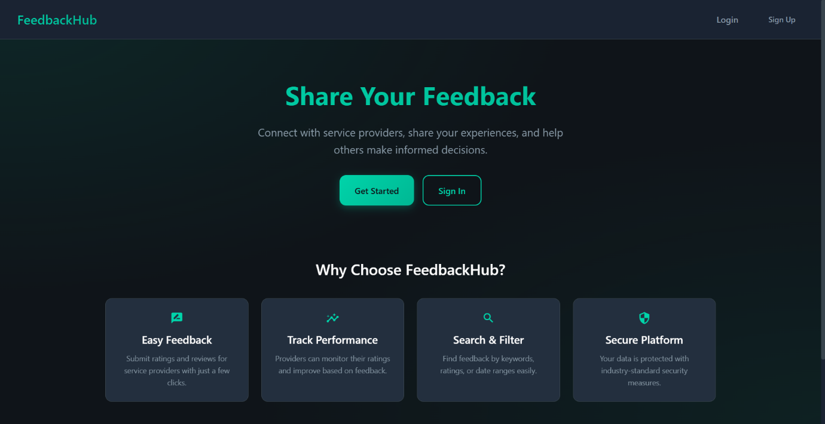

2.AUTHENTICATION MODULE:
A)Login page:
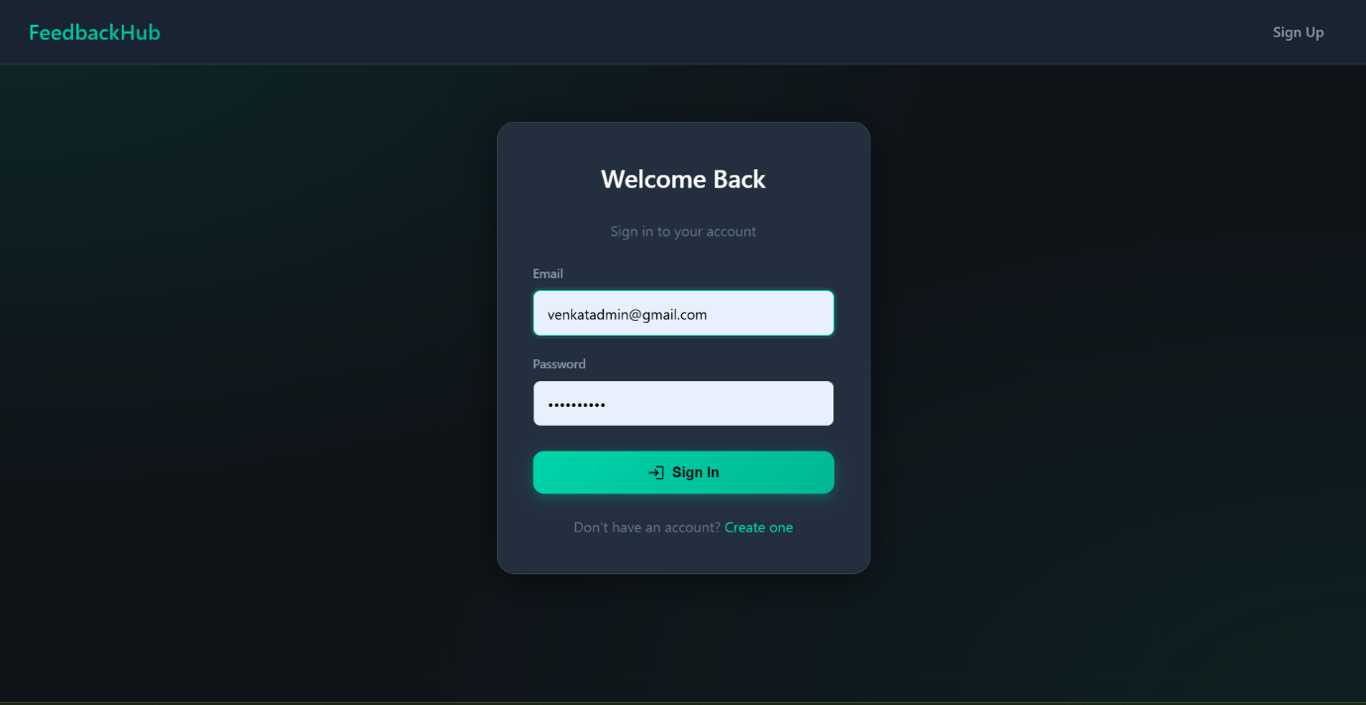

B)Register page:
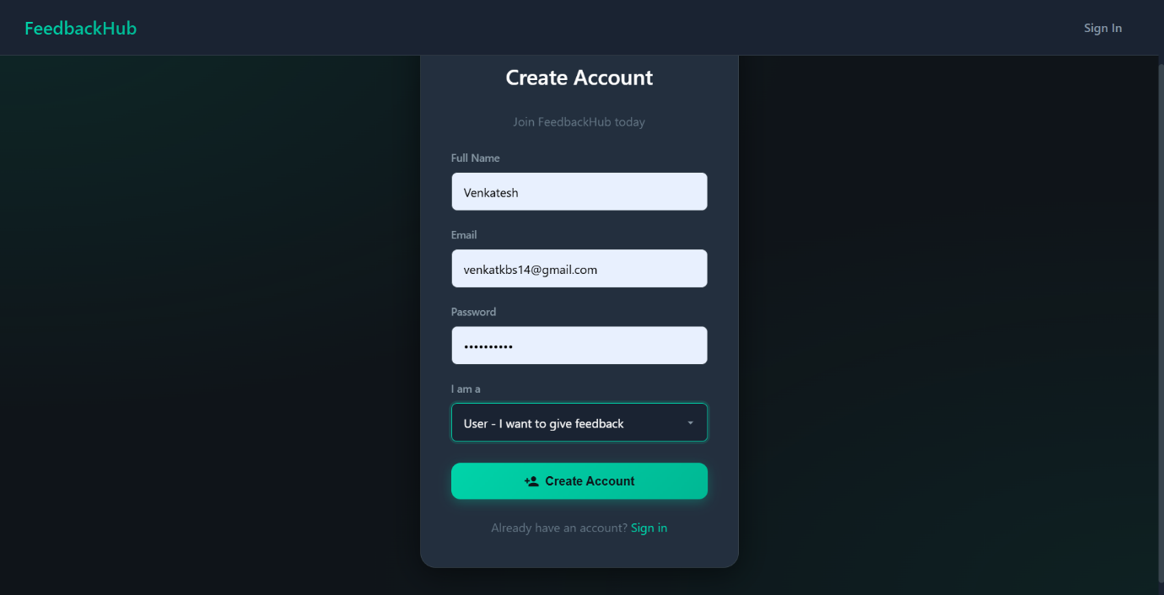

3.USER MODULE:
A)USER DASHBOARD:
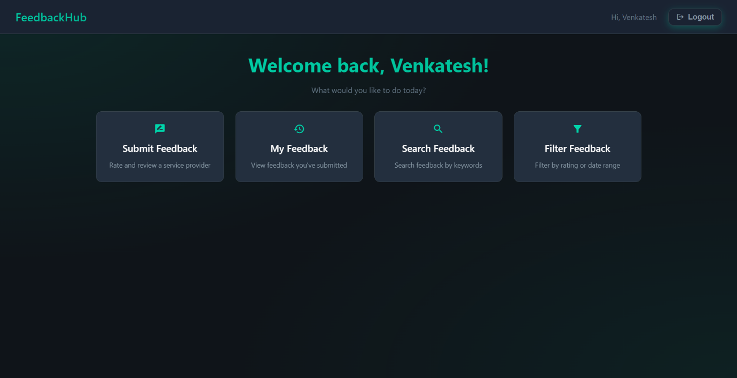

B)SUBMIT FEEDBACK:
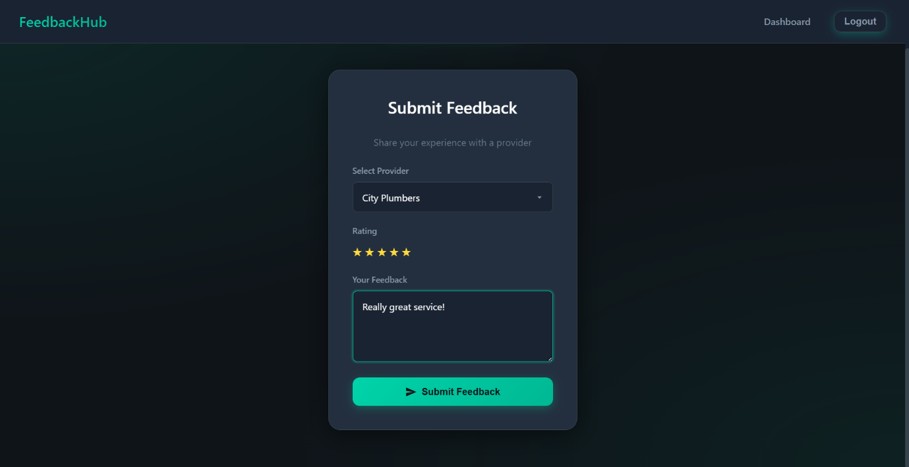
C)VIEW FEEDBACK:
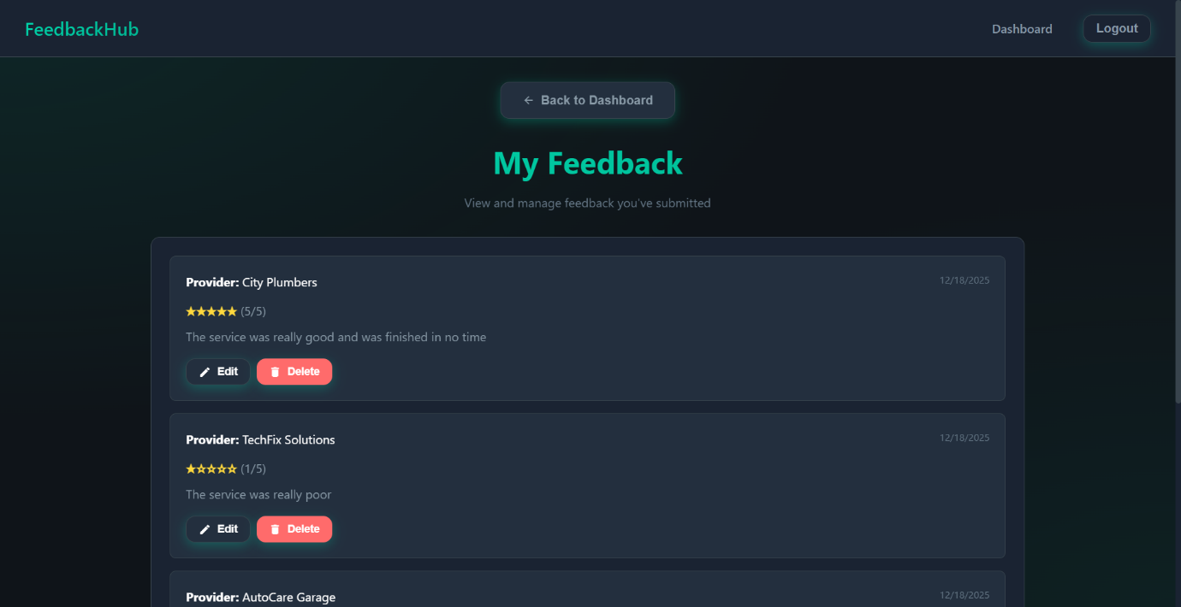

D)SEARCH FEEDBACK:
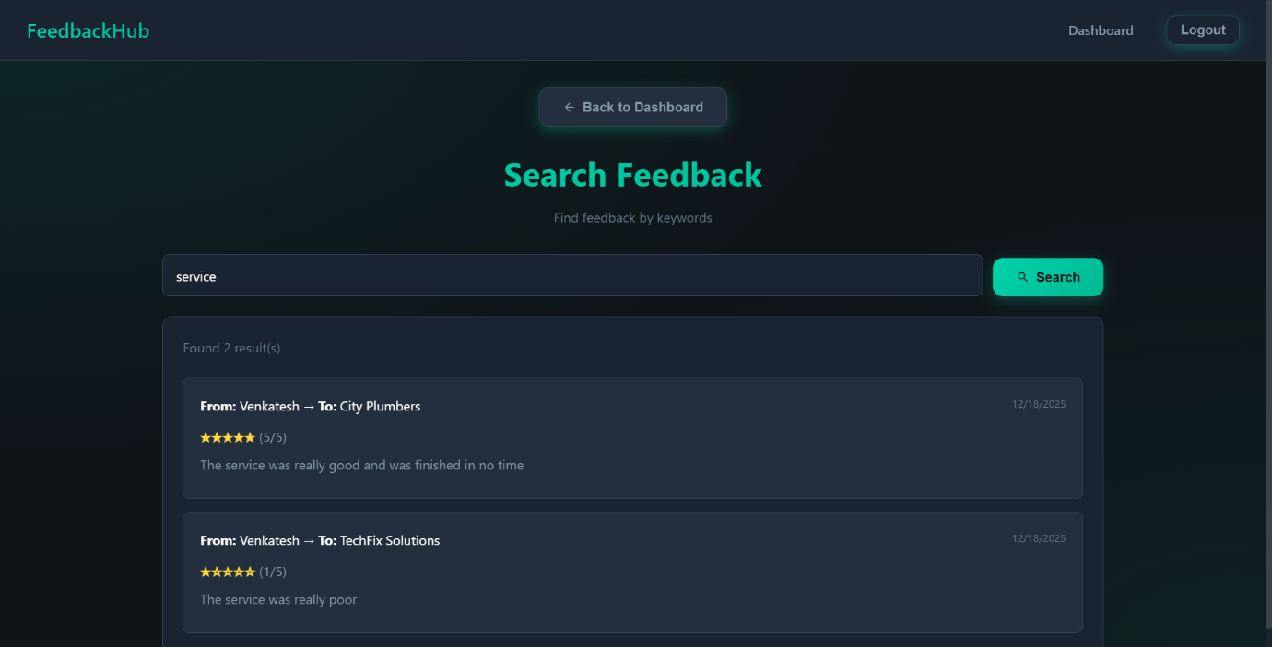
E)FILTER FEEDBACK:
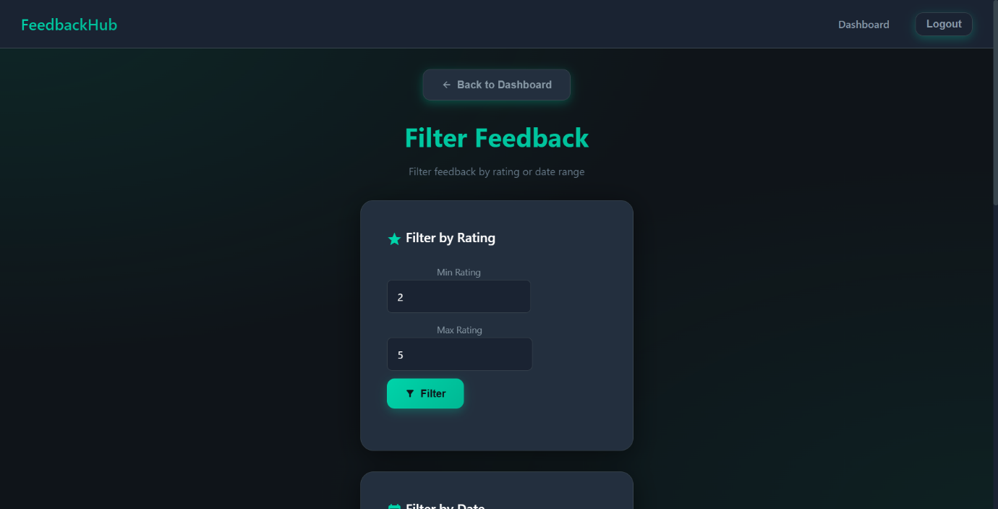
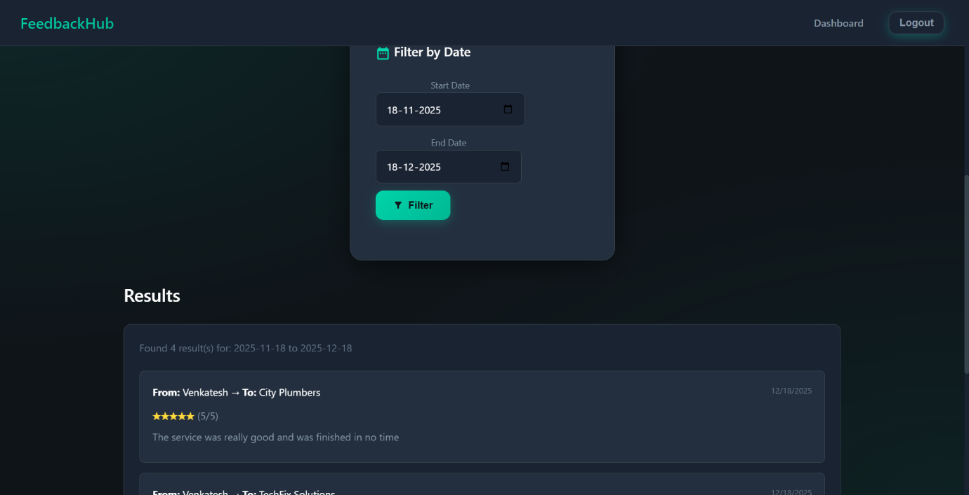

4.PROVIDER MODULE:
A)PROVIDER DASHBOARD:
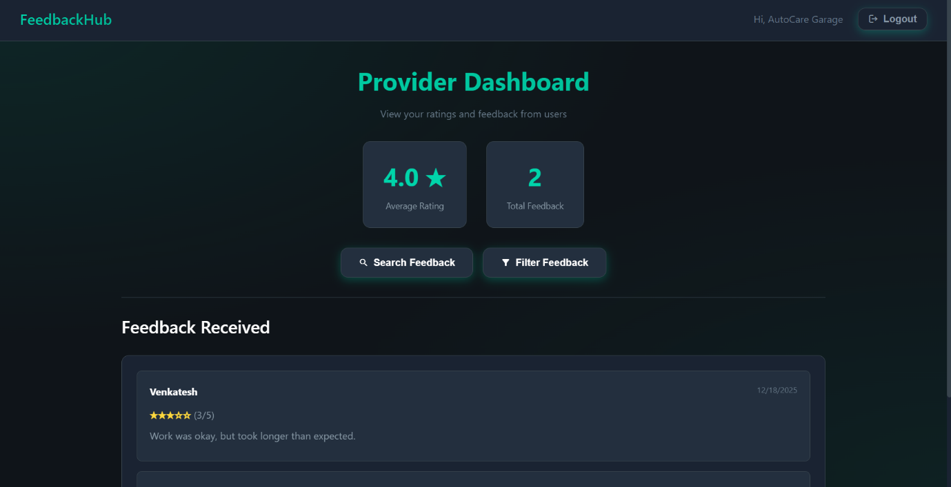

5.ADMIN MODULE:
A)ADMIN DASHBOARD:
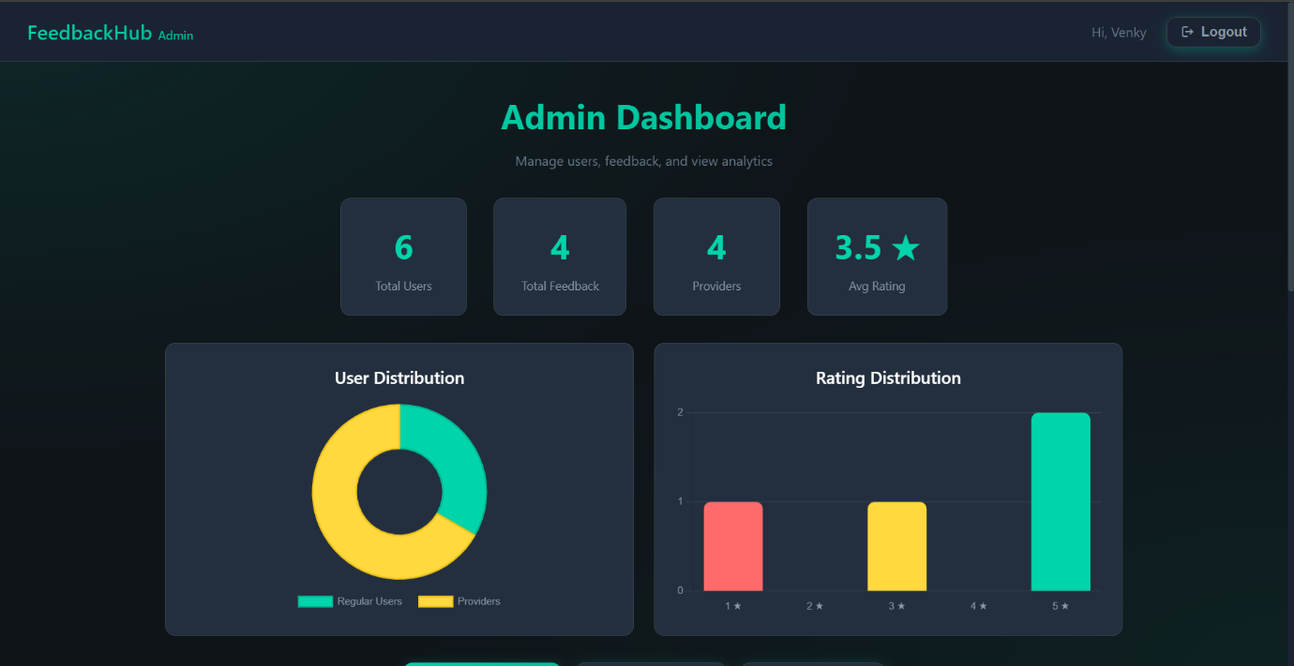
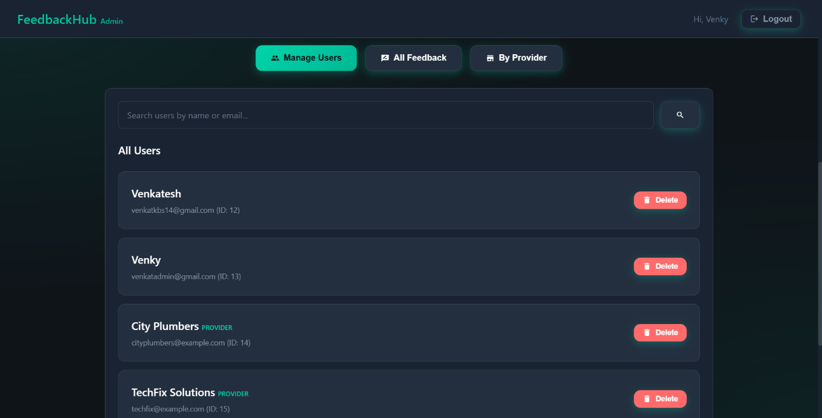

6.DATABASE:
A)DATABASE SCHEMA:
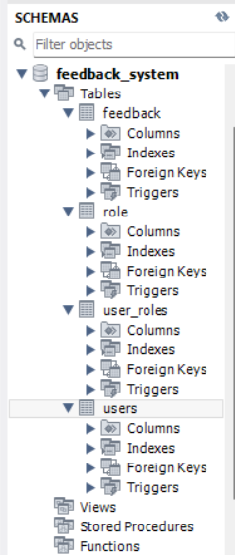
B)USER TABLE STRUCTURE:
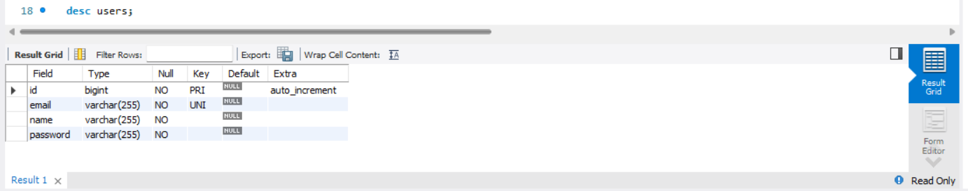

C)USER TABLE:
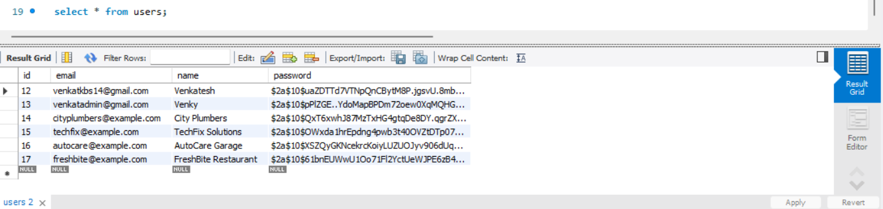
D)ROLE TABLE:
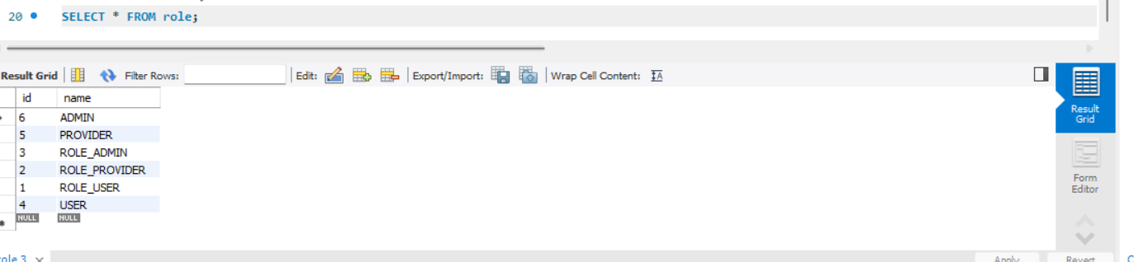

VIDEO DEMONSTRATION
Drive link:
https://drive.google.com/file/d/10WDsADknKZMLWVJ742rvj1dtFu8A4Ww0/view?usp=sharing

